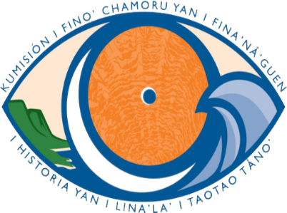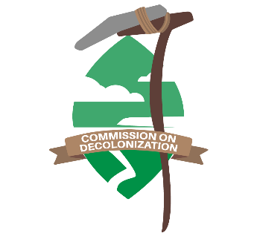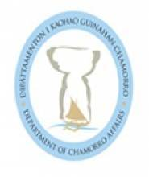
GUAM INDIGENOUS HERITAGE ALLIANCE (GIHA)
Agenda
March 4, 2022
2:00 pm

- Roll Call

- Review of Minutes of Regular Meeting February 4, 2022

- Recap of Official Proclamation and Resolution Sighing of Feb 21, 2022 as Mother Language Day, Kick-off of Mes CHamoru activities and commencement of International Decade of Indigenous Languages and GIHA Network Event on February 18, 2022

- Ideas for celebrating International Decade of Indigenous Languages
- Conference on the State of the CHamoru Language
- Status of Presentations at Indigenous Languages Conference in Taiwan in March 2022 – MWB (Are Rosa SP and Laura TS scheduled to present?)
- Kumision’s Projects: Cultural Dictionary, CHamoru Keyboard, CHamoru Spellcheck App, CHamoru Archives, Minecraft Video Game – we need to post on UN Website

- Community Outreach, what next?

- Updates on Ongoing Issues of Concern

- Reorganization of Historic Preservation, status of new proposed legislation – PL
- Status of National Historic Preservation Guidelines for Islands- MBM
- Naftan Update/Other Burials -PL/MWB
- Cultural Repository – MWB
- Kumisión’s Relocation efforts and change of legal status to Public Non-Profit Corporation – AMA

- Upcoming Mes CHamoru Activities

- New Business
- New Sites for Registry of Historic Places – HP asking that Kumision provide guidance on place names
- Hope requesting for letter from GIHA, victims of radiation survivors – letter to network requesting for support

- Adjournment, Next Meeting April 1, 2022.

